S.NO | CONTENT | PAGE NO
1 | Cover Page
2 | Certificate
3 | Acknowledgement
4 | Table of Contents | 1
5 | Abstract | 2
6 | Introduction | 6
7 | System Analysis | 7
8 | Database Design | 9
9 | Relational Schema | 11
10 | Table Design | 12
11 | Normalization | 15
12 | SQL Implementation | 17
13 | SQL Queries & Screenshots | 20
14 | Conclusion & Future Enhancements | 26
15 | References | 27
TABLE OF CONTENTS

ABSTRACT
The Online Shopping System is a database project designed to organize the core data and transactions of an e-commerce application through a relational database. The system represents users/customers, product categories, products, orders, order items, shopping carts, payment details, and tracking information. These records are connected through primary keys and foreign keys so that related information can be retrieved consistently.The project addresses common problems in poorly structured shopping platforms, such as duplicate customer and product information, slow searches, inconsistent inventory values, difficulty tracking orders, and errors during simultaneous purchases. A structured schema helps separate information into related tables and reduces unnecessary repetition. SQL statements are used to create tables, retrieve records, filter products by price, sort product listings, join order and product information, and calculate summary values such as average employee salary.Normalization is discussed through First Normal Form (1NF), Second Normal Form (2NF), and Third Normal Form (3NF). The project explains how separating order information, product information, and user information reduces partial and transitive dependencies and helps prevent insertion, update, and deletion anomalies. The proposed database provides a foundation for catalog management, customer records, order processing, payment tracking, and delivery-status monitoring.The presentation also identifies transaction safety, data integrity, access security, performance, and scalability as important considerations for a production-ready online shopping system. Features such as automated stock deduction, transaction logging, and secure payment processing are design goals that can be implemented and validated as the database is developed further.

LIST OF FIGURES

S.NO | FIGURE NAME | PAGE NO
1 | Entity–Relationship (ER) Diagram of the Online Shopping System | 10

LIST OF TABLES
S.No. | Table Name | Page No.
1 | Acronyms and Their Expansions | 5
2 | Project Entities and Their Purposes | 9
3 | Entity Relationships and Cardinalities | 9
4 | Relational Schema and Attributes | 11
5 | USERS Table Design | 12
6 | EMPLOYEE Table Design | 12
7 | PRODUCT_CATEGORY Table Design | 13
8 | PRODUCT Table Design | 13
9 | ORDERS Table Design | 13
10 | ORDER_ITEMS Table Design | 14
11 | CART Table Design | 14
12 | TRACKING_DETAIL Table Design | 14
13 | PAYMENT and DELIVERY Table Design | 14
14 | Functional Requirements | 7
15 | Non-Functional Requirements | 8
16 | Requirements Specification | 8
17 | Testing and Validation Set | 24

ACRONYMS
Acronym | Expansion
DBMS | Database Management System
RDBMS | Relational Database Management System
SQL | Structured Query Language
DDL | Data Definition Language
DML | Data Manipulation Language
DQL | Data Query Language
TCL | Transaction Control Language
PK | Primary Key
FK | Foreign Key
ER | Entity–Relationship
1NF | First Normal Form
2NF | Second Normal Form
3NF | Third Normal Form
ACID | Atomicity, Consistency, Isolation, Durability
UPI | Unified Payments Interface

INTRODUCTION

1.1 Brief Information about the Project
The Online Shopping System models the database operations required by an e-commerce platform. Customers need to browse products, review prices and availability, add products to a cart, place orders, make payments, and track deliveries. Administrators need to maintain product details, update prices and quantities, manage categories, and review order information. A relational database stores these connected records in a structured way.
The project uses Oracle-style SQL syntax in its table definitions, including NUMBER, VARCHAR2, and DATE data types. The design separates major entities into tables and uses keys to connect them. The project presentation includes examples of table creation and SQL queries for retrieving users, filtering and sorting products, joining users with orders, joining products with categories, displaying tracking details, and calculating an aggregate value.

1.2 Motivation and Contribution of the Project
In a basic shopping application, keeping customer, product, and order details in a single large table can cause the same information to be repeated many times. Such repetition increases storage needs and makes updates error-prone. A normalized relational design separates data according to its purpose and connects it using identifiers. This project provides practical experience in schema design, constraints, SQL querying, joins, aggregate functions, and normalization.
- Organizes shopping-related information in a centralized relational database.
- Separates users, products, categories, orders, and tracking information into meaningful entities.
- Uses primary and foreign keys to represent relationships between records.
- Supports common retrieval tasks using SELECT, WHERE, ORDER BY, JOIN, and AVG.
- Explains how normalization reduces redundancy and common data anomalies.

1.3 Objectives of the Project
- Design a relational database for an online shopping system.
- Store and maintain user/customer details.
- Manage product categories and product information.
- Represent orders and the products included in each order.
- Maintain cart and order-tracking information.
- Demonstrate SQL table creation and data retrieval.
- Apply 1NF, 2NF, and 3NF to reduce redundancy.
- Identify data integrity, concurrency, security, and performance requirements for future development.

1.4 Scope of the Project
The current academic scope covers database design and SQL operations for users, employees, product categories, products, orders, carts, and tracking details. The presentation also describes payment and delivery as important e-commerce data areas. The system can be extended with dedicated payment and delivery tables, inventory transaction logs, discount management, customer reviews, returns, and a web or mobile interface. Actual payment-gateway integration, production authentication, and live delivery integration are outside the SQL examples shown in the presentation.

2. SYSTEM ANALYSIS

2.1 Existing System
A poorly structured or manual shopping-record system may keep customer details, product information, and order records in disconnected files or repeated rows. Searching for a particular product or order can take extra time, and the same customer or product details may need to be updated in multiple places. During high-demand periods, uncoordinated stock updates can also result in incorrect stock values or overselling.
- Repeated customer and product details across order records.
- Difficulty maintaining consistent product quantity and price information.
- Slow searching and reporting when information is stored in disconnected records.
- Limited traceability between customers, orders, payments, and deliveries.
- Higher risk of insertion, update, and deletion anomalies.

2.2 Proposed System
The proposed system organizes the information into related tables. Users are identified by a user ID, products by a product ID, categories by a category ID, and orders by an order number. Foreign-key relationships connect products to categories, orders to users, and tracking records to orders. In a normalized design, order header information is kept separately from individual order items so that one order can contain multiple products without repeating unrelated customer and product details.
- Centralized and structured storage of shopping records.
- Product listing and price-based filtering/sorting.
- Relational links between users, products, categories, orders, and tracking.
- SQL-based retrieval and reporting.
- Normalized order and product data to reduce redundancy.

2.3 Functional Requirements
Module | Functional Requirement
User Management | Create, update, search, and display user/customer details.
Product Category | Store category names and category types.
Product Management | Maintain product name, price, description, and category.
Cart Management | Record cart identifiers, quantities, dates, and associated users.
Order Management | Record order date, customer/user reference, and order amount/status.
Order Items | Represent individual products and quantities belonging to an order.
Payment | Store payment mode, amount, status, and associated order where implemented.
Tracking / Delivery | Maintain tracking status and current location for an order.
Search and Reporting | Retrieve filtered, sorted, joined, and aggregated data using SQL.

2.4 Non-Functional Requirements
Requirement | Description
Integrity | Primary and foreign keys should prevent duplicate identifiers and invalid references.
Security | Access to customer and payment-related information should be restricted to authorized users.
Performance | Frequently used product and order queries should execute efficiently.
Reliability | Transactions should preserve consistent records when an operation succeeds or fails.
Scalability | The design should support increasing numbers of users, products, and orders.
Maintainability | Separate tables and clearly named columns make the database easier to modify.

2.5 Requirements Specification
Category | Suggested Requirement
Hardware | Computer with a modern processor, at least 4 GB RAM, and adequate storage.
Operating System | Windows 10/11 or another supported operating system.
Database | Oracle Database or an equivalent relational DBMS; the presentation uses Oracle-style SQL.
Software | SQL client such as SQL Developer or another tool compatible with the selected DBMS.
User Skills | Basic understanding of SQL, tables, keys, joins, and normalization.

3. DATABASE DESIGN

3.1 Major Entities
Entity | Purpose
USERS | Stores user identity and contact details such as name, email, and address.
EMPLOYEE | Stores employee ID, joining date, salary, and optional link to a user record in the supplied examples.
PRODUCT_CATEGORY | Stores product category identifiers, names, and category types.
PRODUCT | Stores product name, price, description, and category reference.
ORDERS | Stores order-level information such as order number, user, and order date.
ORDER_ITEMS | Stores the products and quantities included in each order.
CART | Stores cart records and the user associated with each cart.
TRACKING_DETAIL | Stores order status and current location for tracking.
PAYMENT | A conceptual entity in the presentation for payment mode, amount, status, and order reference.
DELIVERY | A conceptual entity in the presentation for delivery date, address, and status.

3.2 ER Model
The Entity-Relationship (ER) Model represents the main entities involved in the Online Shopping System and their attributes. It provides a conceptual view of the database structure and helps in understanding how data is organized. The major entities include USERS, EMPLOYEE, PRODUCT_CATEGORY, PRODUCT, ORDERS, ORDER_ITEMS, CART, PAYMENT, DELIVERY, and TRACKING_DETAIL.
Each entity contains attributes that describe its information. Primary Keys (PK) uniquely identify records in a table, while Foreign Keys (FK) connect related tables. For example, User_ID identifies each user, Product_ID identifies each product, and Category_ID identifies each product category.

3.3 Relationships
Relationship | Cardinality / Meaning
USERS — ORDERS | One user can place many orders; each order belongs to a user.
PRODUCT_CATEGORY — PRODUCT | One category can contain many products; each product references a category.
ORDERS — ORDER_ITEMS | One order can contain multiple order-item rows.
PRODUCT — ORDER_ITEMS | One product can appear in many order-item rows.
USERS — CART | One user can be associated with one or more cart records.
ORDERS — TRACKING_DETAIL | An order can have tracking records; each tracking row refers to an order.
ORDERS — PAYMENT | A payment record refers to the order it is intended to pay for.
ORDERS — DELIVERY | Delivery information is associated with an order.

4.ER DIAGRAM
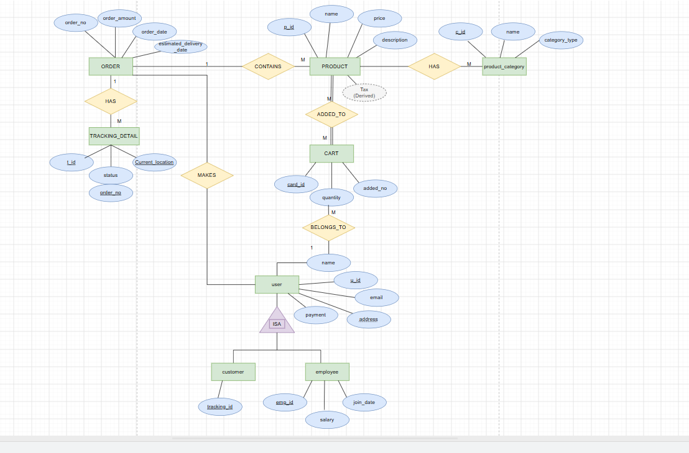
Figure 1. Entity–Relationship (ER) Diagram of the Online Shopping System
The ER diagram represents the entities, attributes, and relationships in the Online Shopping System. The main entities are ORDER, PRODUCT, PRODUCT_CATEGORY, CART, USER, TRACKING_DETAIL, CUSTOMER, and EMPLOYEE. Each entity contains attributes such as order number, product ID, price, quantity, user ID, and current location. A user can place orders, and each order can contain products and have tracking details. Products belong to product categories and can be added to the cart. The USER entity is divided into CUSTOMER and EMPLOYEE using an ISA relationship. This ER model helps organize the database and shows how different entities are connected in the online shopping process.

5. RELATIONAL SCHEMA

The following schema is a normalized documentation-level representation of the entities and relationships described in the presentation. The team should compare it with the final database objects in the SQL client before submission.
Relation | Attributes (PK = Primary Key, FK = Foreign Key)
USERS | u_id (PK), name, email, address, payment
EMPLOYEE | emp_id (PK), u_id (FK), join_date, salary
PRODUCT_CATEGORY | c_id (PK), name, category_type
PRODUCT | p_id (PK), name, price, description, c_id (FK)
ORDERS | order_no (PK), u_id (FK), order_date, order_amount, order_status
ORDER_ITEMS | order_no (PK, FK), product_id (PK, FK), quantity, unit_price
CART | cart_id (PK), quantity, added_on, u_id (FK)
TRACKING_DETAIL | t_id (PK), status, order_no (FK), current_location
PAYMENT | payment_id (PK), order_no (FK), payment_mode, amount, payment_status
DELIVERY | delivery_id (PK), order_no (FK), delivery_date, address, status
The Online Shopping System database contains ten relations: USERS, EMPLOYEE, PRODUCT_CATEGORY, PRODUCT, ORDERS, ORDER_ITEMS, CART, TRACKING_DETAIL, PAYMENT, and DELIVERY. Each relation stores specific information about users, products, orders, and deliveries. Primary Keys (PK) uniquely identify records, while Foreign Keys (FK) connect related tables. This relational structure helps organize data and maintain consistency in the database.

6. TABLE DESIGN
The tables below describe the intended fields and constraints. Exact lengths and optionality can be adjusted to match the final SQL implementation.

6.1 USERS Table
Column | Suggested Type | Constraint / Description
u_id | NUMBER | Primary key; unique user identifier
name | VARCHAR2(100) | User's display name
email | VARCHAR2(150) | Email address; preferably UNIQUE
address | VARCHAR2(250) | Contact/delivery address
payment | VARCHAR2(30) | Optional preferred payment mode in the supplied example

6.2 EMPLOYEE Table
Column | Suggested Type | Constraint / Description
emp_id | NUMBER | Primary key
u_id | NUMBER | Foreign key referencing USERS(u_id), if employees are linked to users
join_date | DATE | Employee joining date
salary | NUMBER(10,2) | Employee salary

6.3 PRODUCT_CATEGORY Table
Column | Suggested Type | Constraint / Description
c_id | NUMBER | Primary key
name | VARCHAR2(100) | Category name
category_type | VARCHAR2(50) | Category classification

6.4 PRODUCT Table
Column | Suggested Type | Constraint / Description
p_id | NUMBER | Primary key
name | VARCHAR2(150) | Product name
price | NUMBER(10,2) | Product price
description | VARCHAR2(500) | Product description
c_id | NUMBER | Foreign key referencing PRODUCT_CATEGORY(c_id)

6.5 ORDERS Table
Column | Suggested Type | Constraint / Description
order_no | NUMBER | Primary key
u_id | NUMBER | Foreign key referencing USERS(u_id)
order_date | DATE | Date the order was placed
order_amount | NUMBER(10,2) | Total amount for the order
order_status | VARCHAR2(30) | Order status such as Placed, Shipped, Delivered, or Cancelled

6.6 ORDER_ITEMS Table
Column | Suggested Type | Constraint / Description
order_no | NUMBER | Composite primary key part; FK to ORDERS
product_id | NUMBER | Composite primary key part; FK to PRODUCT
quantity | NUMBER | Quantity of the product ordered
unit_price | NUMBER(10,2) | Price per unit at the time of purchase

6.7 CART Table
Column | Suggested Type | Constraint / Description
cart_id | NUMBER | Primary key
quantity | NUMBER | Quantity currently in the cart
added_on | DATE | Date the cart record was added
u_id | NUMBER | Foreign key referencing USERS(u_id)

6.8 TRACKING_DETAIL Table
Column | Suggested Type | Constraint / Description
t_id | NUMBER | Primary key
status | VARCHAR2(50) | Current tracking status
order_no | NUMBER | Foreign key referencing ORDERS(order_no)
current_location | VARCHAR2(100) | Current shipment location

6.9 PAYMENT and DELIVERY
Entity | Suggested fields
PAYMENT | payment_id (PK), order_no (FK), payment_mode, amount, payment_status
DELIVERY | delivery_id (PK), order_no (FK), delivery_date, address, status

7. NORMALIZATION

Normalization is the process of structuring relational tables to reduce unnecessary duplication and improve data consistency. The presentation discusses 1NF, 2NF, and 3NF using order data as the main example.

7.1 First Normal Form (1NF)
A relation is in 1NF when each field contains a single, atomic value and repeating groups are not stored in one column. For example, an order should not store a list of several product IDs in a single text field; individual product entries should be represented as separate rows.

7.2 Second Normal Form (2NF)
A relation is in 2NF when it is in 1NF and every non-key attribute depends on the whole candidate key. In an ORDER_ITEM table with a composite key (Order_ID, Product_ID), quantity and the price charged for that product line should depend on the full order-item key, not on only one part of it.

7.3 Third Normal Form (3NF)
A relation is in 3NF when it is in 2NF and non-key attributes do not depend transitively on the key. Category names should be stored in PRODUCT_CATEGORY rather than repeated for every product, and user details should be maintained in the USER table rather than duplicated in every order. The project presentation states that normalization up to 3NF is applied to reduce redundancy and insertion, deletion, and update anomalies.

7.4 Benefits of Normalization
- Reduces repeated customer and product information.
- Prevents conflicting copies of the same email, product name, or price.
- Allows a customer or product to exist before an order is placed.
- Reduces the risk of losing customer/product details when an order is deleted.
- Improves maintainability and makes relationships easier to understand.

8. SQL IMPLEMENTATION
The project presentation uses Oracle-style SQL. The scripts below provide a consistent example of the intended normalized structure. If tables already exist in the team's database, compare names and constraints before running the statements. Run table creation in parent-to-child order so that referenced tables exist first.

8.1 DDL-DATA DEFINITION LANGUAGE
CREATE TABLE users (
u_id NUMBER PRIMARY KEY,
name VARCHAR2(100) NOT NULL,
email VARCHAR2(150) UNIQUE,
address VARCHAR2(250),
payment VARCHAR2(30)
);

CREATE TABLE product_category (
c_id NUMBER PRIMARY KEY,
name VARCHAR2(100) NOT NULL,
category_type VARCHAR2(50)
);

CREATE TABLE employee (
emp_id NUMBER PRIMARY KEY,
u_id NUMBER,
join_date DATE,
salary NUMBER(10,2),
CONSTRAINT fk_employee_user
FOREIGN KEY (u_id) REFERENCES users(u_id)
);

8.2 DML-DATA MANIPULATION LANGUAGE
CREATE TABLE product (
p_id NUMBER PRIMARY KEY,
name VARCHAR2(150) NOT NULL,
price NUMBER(10,2) CHECK (price >= 0),
description VARCHAR2(500),
c_id NUMBER,
CONSTRAINT fk_product_category
FOREIGN KEY (c_id) REFERENCES product_category(c_id)
);

CREATE TABLE orders (
order_no NUMBER PRIMARY KEY,
u_id NUMBER NOT NULL,
order_date DATE DEFAULT SYSDATE,
order_amount NUMBER(10,2) CHECK (order_amount >= 0),
order_status VARCHAR2(30),
CONSTRAINT fk_orders_user
FOREIGN KEY (u_id) REFERENCES users(u_id)
);

CREATE TABLE order_items (
order_no NUMBER,
product_id NUMBER,
quantity NUMBER NOT NULL CHECK (quantity > 0),
unit_price NUMBER(10,2) NOT NULL CHECK (unit_price >= 0),
CONSTRAINT pk_order_items PRIMARY KEY (order_no, product_id),
CONSTRAINT fk_items_order FOREIGN KEY (order_no)
REFERENCES orders(order_no),
CONSTRAINT fk_items_product FOREIGN KEY (product_id)
REFERENCES product(p_id)
);

8.3 DQL- DATA QUERY LANGUAGE
CREATE TABLE cart (
cart_id NUMBER PRIMARY KEY,
quantity NUMBER CHECK (quantity >= 0),
added_on DATE DEFAULT SYSDATE,
u_id NUMBER,
CONSTRAINT fk_cart_user
FOREIGN KEY (u_id) REFERENCES users(u_id)
);

CREATE TABLE tracking_detail (
t_id NUMBER PRIMARY KEY,
status VARCHAR2(50),
order_no NUMBER,
current_location VARCHAR2(100),
CONSTRAINT fk_tracking_order
FOREIGN KEY (order_no) REFERENCES orders(order_no)
);

8.4 Optional Payment and Delivery Tables
The presentation identifies PAYMENT and DELIVERY in the high-level schema. The following definitions can be used if these entities are included in the actual implementation.
CREATE TABLE payment (
payment_id NUMBER PRIMARY KEY,
order_no NUMBER NOT NULL,
payment_mode VARCHAR2(30),
amount NUMBER(10,2) CHECK (amount >= 0),
payment_status VARCHAR2(30),
CONSTRAINT fk_payment_order
FOREIGN KEY (order_no) REFERENCES orders(order_no)
);

CREATE TABLE delivery (
delivery_id NUMBER PRIMARY KEY,
order_no NUMBER NOT NULL,
delivery_date DATE,
address VARCHAR2(250),
status VARCHAR2(50),
CONSTRAINT fk_delivery_order
FOREIGN KEY (order_no) REFERENCES orders(order_no)
);

9. SQL QUERIES AND EXPECTED USE
The following queries are based on the query examples shown in the project presentation. They illustrate basic selection, projection, filtering, sorting, joins, and aggregate functions.

Q1.Display all users

SELECT * FROM users;
OUTPUT:
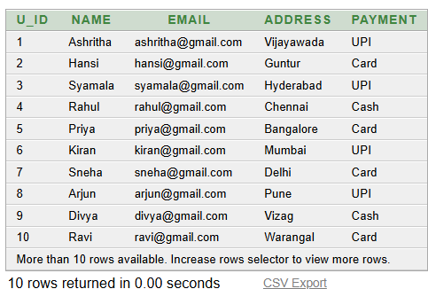

Q2. Display user names and emails

SELECT name, email FROM users;
OUTPUT:
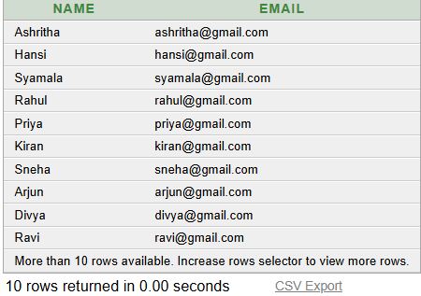

Q3. Find products priced above 5000

SELECT * FROM product WHERE price > 5000;
OUTPUT:
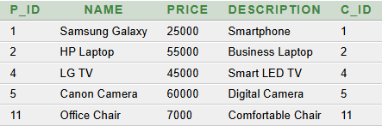

Q4 .Find products priced between 1000 and 10000

SELECT * FROM product WHERE price BETWEEN 1000 AND 1000
OUTPUT:
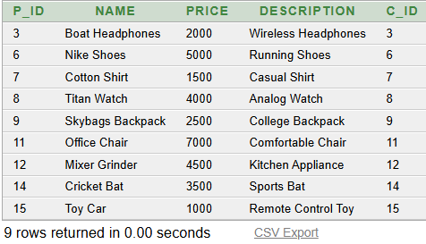

Q5. Sort products by ascending price

SELECT * FROM product ORDER BY price ASC;
OUTPUT:
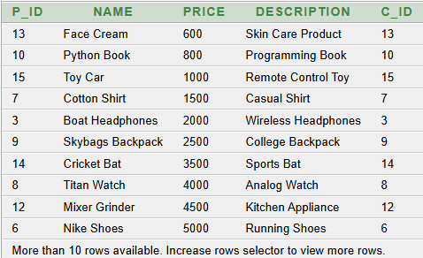

Q6. Display users with their orders

SELECT u.u_id, u.name, o.order_no, o.order_amount
FROM users u
JOIN orders o ON u.u_id = o.u_id;
OUTPUT:
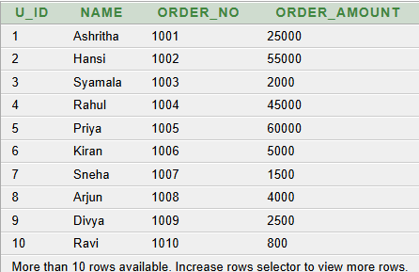

Q7. Display products with category names

SELECT p.p_id, p.name, p.price,
pc.name AS category_name
FROM product p
JOIN product_category pc ON p.c_id = pc.c_id;
OUTPUT:
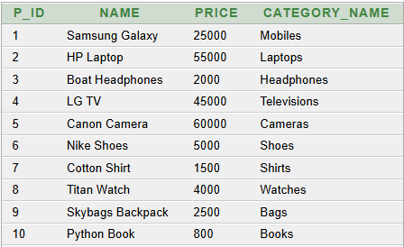

Q8. Display tracking information with orders

SELECT t.t_id, t.status, t.current_location,
o.order_no, o.order_amount
FROM tracking_detail t
JOIN orders o ON t.order_no = o.order_no;
OUTPUT:
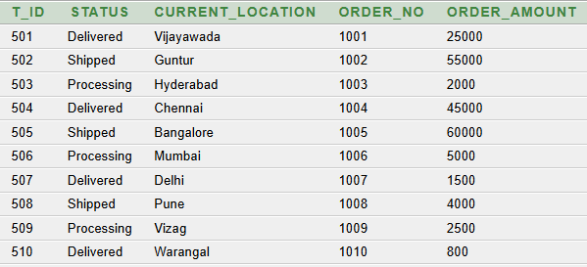
.Q9. Calculate average employee salary

SELECT AVG(salary) AS average_salary FROM employee;
OUTPUT:
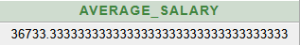

Q10. Find users with UPI payment preference

SELECT * FROM users WHERE payment = 'UPI';
OUTPUT:
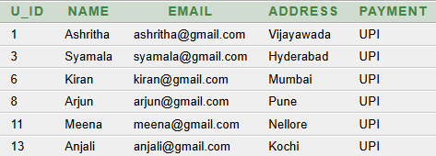

10. ANOMALIES AND DATA REDUNDANCY
Anomalies are problems that can occur when the same facts are stored repeatedly in a poorly structured table. The presentation identifies insertion, update, and deletion anomalies, along with data redundancy.

10.1 Insertion Anomaly
An insertion anomaly occurs when one type of information cannot be added without supplying unrelated information. For example, if customer details are stored only in an order table, a new customer who has not placed an order may not be recorded without creating an artificial order. Keeping customer information in USERS allows the customer to be registered independently.

10.2 Update Anomaly
An update anomaly occurs when the same fact appears in multiple rows and each copy must be changed. If a customer's email address is repeated in several order rows, updating only some of those rows creates inconsistent data. Storing the email once in USERS means that the update can be made in one place.

10.3 Deletion Anomaly
A deletion anomaly occurs when removing one record unintentionally removes other information that should be retained. If a customer's details exist only in a row representing an order, deleting the last order could also remove the only copy of the customer's details. Separate USERS and ORDERS tables help avoid this problem.

10.4 Data Redundancy
Data redundancy means storing the same information unnecessarily in multiple places. Repeating customer names, email addresses, product names, and product prices in every order row increases storage and the risk of inconsistency. Foreign keys and normalized tables reduce this duplication.

11. TESTING AND VALIDATION
Testing should confirm that the database objects are created successfully, relationships behave as expected, and queries return results consistent with the inserted sample records. The presentation contains query examples and output placeholders; actual execution evidence should be captured from the database tool used by the team.
Test Case | Action | Expected Result
Table creation | Create parent tables before dependent tables. | Tables are created without missing-reference errors.
Primary key | Attempt to insert duplicate primary-key values. | The DBMS rejects the duplicate.
Foreign key | Insert a product with a non-existing category ID. | The DBMS rejects the invalid reference when the FK is enabled.
Price filter | Run the query for products with price > 5000. | Only products meeting the condition are returned.
Price sorting | Run ORDER BY price ASC. | Products appear from lower to higher price.
User-order join | Join USERS and ORDERS using u_id. | Each returned row shows a matching user and order.
Category join | Join PRODUCT and PRODUCT_CATEGORY using c_id. | Each returned row shows a product and its category.
Aggregate query | Run AVG(salary) on EMPLOYEE. | A single average value is returned, or NULL if no non-NULL salaries exist.
Normalization review | Check whether user and product details are repeated in order items. | Order-related tables store identifiers and order-specific values rather than duplicate descriptive details.

Before final submission, insert screenshots of successful CREATE TABLE statements, table structures, sample records, and the output of the SQL queries. Do not label a screenshot as successful unless it is taken from an actual execution.

12. CONCLUSION
The Online Shopping System project demonstrates how relational database concepts can be applied to the core operations of an e-commerce application. The design organizes user, product, category, order, cart, and tracking information into related entities. SQL examples demonstrate data retrieval, filtering, sorting, joins, and aggregate functions. The normalization section explains how 1NF, 2NF, and 3NF reduce redundant data and help prevent insertion, update, and deletion anomalies.
The project also identifies data integrity, security, transaction safety, performance, and scalability as important requirements. A normalized schema and appropriate key constraints provide a foundation for consistent data management. Further validation against the actual database implementation is important, particularly to ensure that table names and relationships match the SQL scripts and that all screenshots represent executed queries.
13.FUTURE ENHANCEMENTS
- Implement a dedicated ORDER_ITEMS table and separate order headers from product-level details.
- Add inventory quantity validation and safe stock updates during checkout.
- Use database transactions with COMMIT and ROLLBACK to protect multi-step order operations.
- Add triggers or stored procedures for stock deduction and audit logging after successful order placement.
- Implement a dedicated payment table and connect it to an order using a foreign key.
- Add delivery history, shipment status timestamps, and customer notifications.
- Create indexes for frequently searched product names, category IDs, and order references where justified by query performance.
- Apply role-based database permissions and secure handling of authentication/payment information.
- Develop a web or mobile interface for customer shopping and administrator operations.
- Test the database with larger sample datasets and concurrent order scenarios.

14. REFERENCES
1. Korth, H. F., Silberschatz, A., and Sudarshan, S., Database System Concepts, McGraw Hill.
2. Elmasri, R. and Navathe, S. B., Fundamentals of Database Systems, Pearson.
3.Raghu Ramakirshna and Johannes Gehrke, Database management System 3rd Edition
4. Ramez Elmasri and Shamkant B.Navathe, Fundamentals of Database System
5.C.J Date,An Introduction to Database System
6. Dr.Rajiv Chopra , Database Management Systems

